New DEBUG tools page

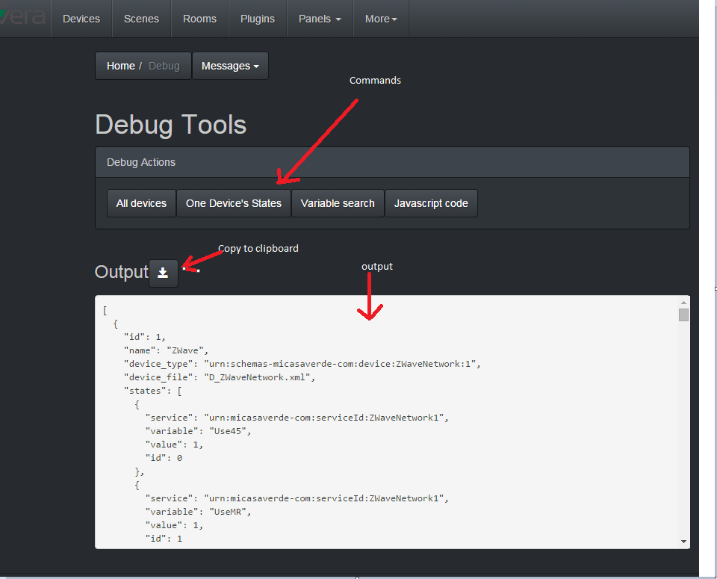

All devices :

* Same as jsonp, or user_data.devices. everything about everything ( device , states, scenes, etc )
* in a multicontroller mode , so if you have multiple controllers you see them all

One device state:

* You are asked to input a device ID first. This device ID is in the multi controller format, that is:
  + cc-nn , where cc is the controller index ( 0,1,… ) and nn is the device.id on this controller
* Then you see all the variables & servicename & values for that device

Variable search:

* You are asked for a variable name and it will return the devices that have a variable that matches this name, as well as the values
* This is a javascript pattern matching so you can use javascript RegExp characters if you want. By default the search is based on a contained-in rule so “Route” will match “AutoRoute” and “ManualRoute” and “LastRouteUpdate” for instance

Javascript code:

* A javascript expression that is evaluated ( safely, in a try/catch ) , then displayed in a JSON , pretty print format
* All API of ALTUI can be called , so for instance all the methods of the MultiBox object can be called. For instance, You can try
  + MultiBox.getBoxInfo()
  + MultiBox.getControllers()
  + Etc..

